

**West Coast Collaborative**

**Specialist Mathematics Units 3 & 4**

**Test 1 2018**

**Calculator Free Section**

**Name: __________________________ Score: _____ / 20**

**Time Allowed**: 20 minutes **Total Marks**: 20

**Materials Allowed**: SCSA formula booklet

**Instructions:** Where a question or part of a question is worth more than 2 marks sufficient working to justify your solution is required.

1. **[7, 1, 2, 1 marks]**

One of the three cube roots of a complex number ***Z*** is $z_{1}$, where $z_{1}=2\left(i-\sqrt{3}\right)$.

1. On the Argand plane, accurately sketch the 3 cube roots of ***Z.***

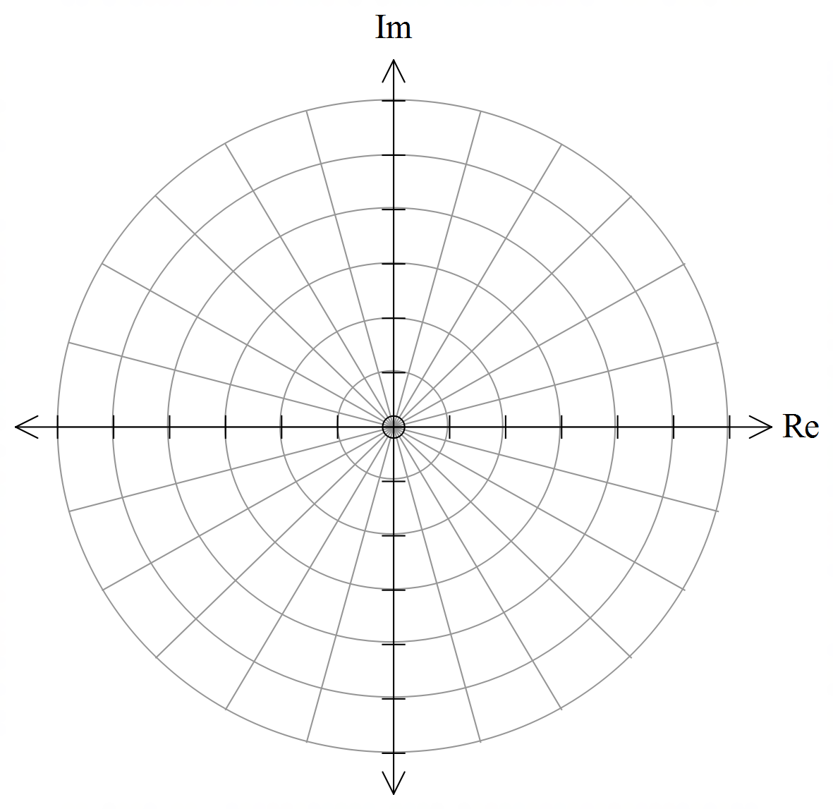

1. Determine as exact values:
 $z_{1}+z_{2}+z_{3}$

 $z_{1}×z_{2}×z_{3}$ 1. in polar form
   2. ***Z*** in polar form
2. **[4 marks]**

The diagram below shows the unit circle in the complex plane and the position of three complex numbers

***w****,* ***u***and ***v***.

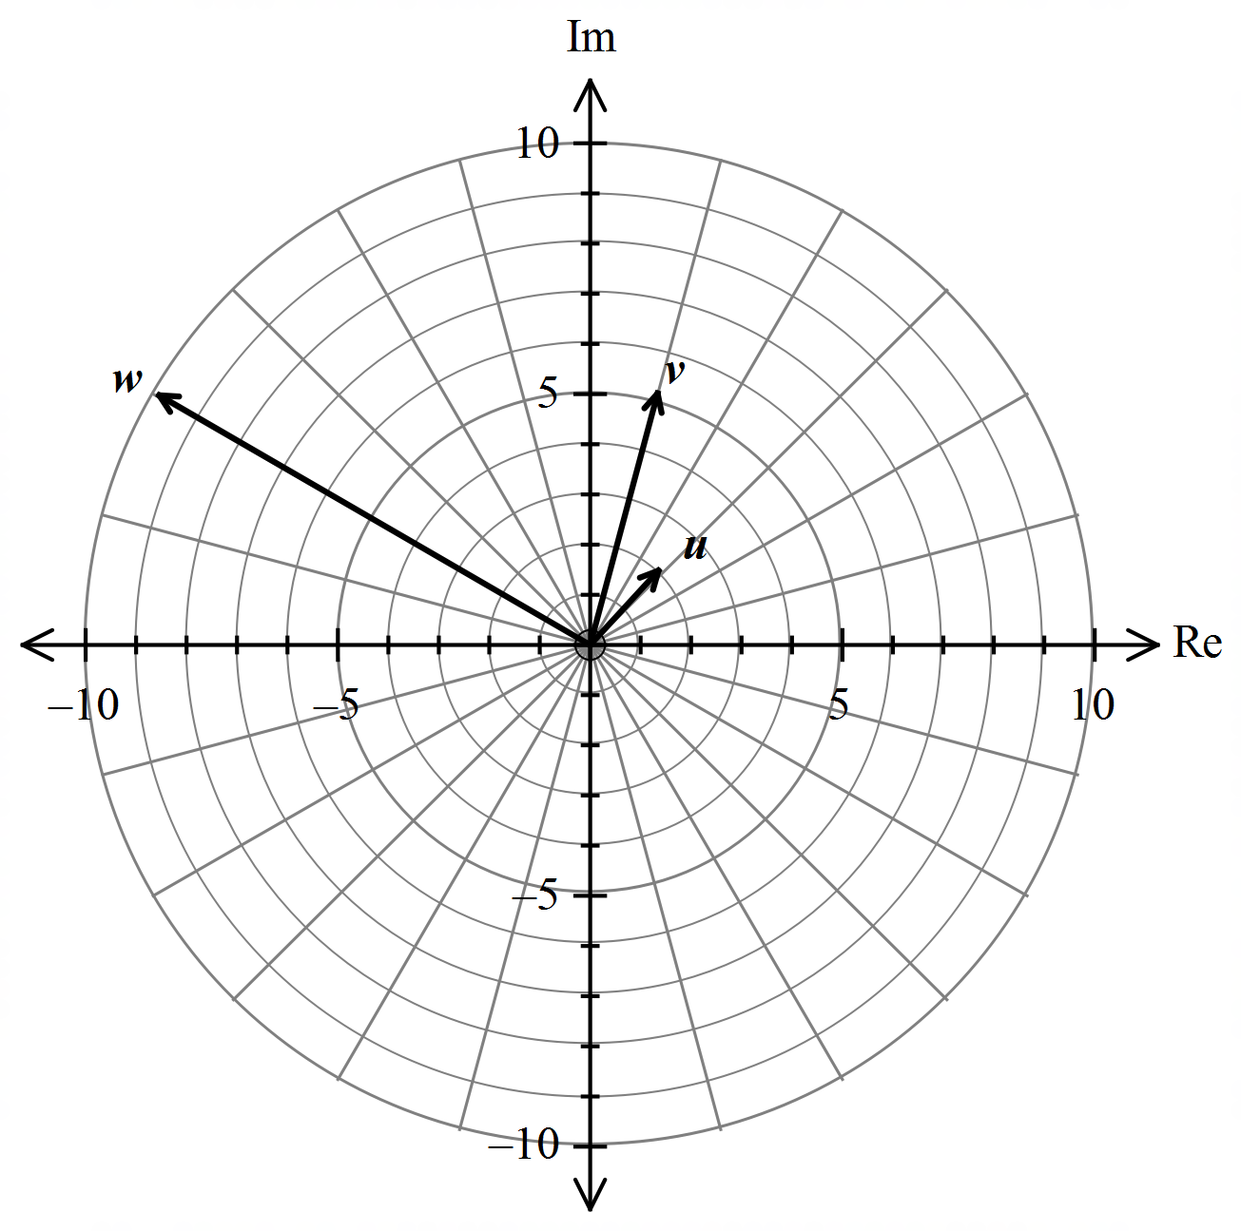

On the diagram above plot the following:

a. $z_{1}=uv$

b. $z_{2}=\frac{1}{w}$

c. $z_{3}=i\overline{v}$

d. $z_{4}=v-2u$

1. **[5 marks]**

The polynomial $P\left(z\right)=3z^{4}-3z^{3}+az^{2}+bz-3$ has a factor of $z+1$ and leaves a remainder of 51 when $P(z)$ is divided by $z-2$. Determine the values of *a* and *b*.



**West Coast Collaborative**

**Specialist Mathematics Units 3 & 4**

**Test 1 2018**

**Calculator Assumed Section**

**Name: _______________________ Score: _____ / 36**

**Time Allowed**: 35 minutes **Total Marks**: 36

**Materials Allowed**: SCSA formula booklet, SCSA approved calculators and one A4 page of notes (both sides).

**Instructions:** Where a question or part of a question is worth more than 2 marks sufficient working to justify your solution is required.

1. **[6 marks]**

Solve the equation $z^{3}+z^{2}-z+15=0$.

1. **[3, 3 marks]**

**a.** Given $z=rcisθ$, prove that $\overline{z}+\frac{1}{z}=\frac{\left(r^{2}+1\right)}{r}\overline{z}$

b. Hence, show that ${\left(\sqrt{3}+i+\frac{1}{\sqrt{3}-i}\right)}^{n}= {\left(\frac{5}{2}\right)}^{n}cis\frac{nπ}{6}$

1. **[4, 4 marks]**

Two complex numbers are given by $u=3i$ and $v=\frac{-3\sqrt{2}-3\sqrt{2}i}{2}$

a. Express $u^{3}v$ in the form $rcisθ$, where $-π<θ≤π$ and $r≥0$.

b. Use de Moivre’s theorem to determine all the solutions for $z$ in polar form, given $z^{4}=u^{3}v$.

1. **[5, 2 marks]**

a. Sketch in the complex plane the region satisfying the two inequalities given by

$$\left|z-\sqrt{3}-i\right|≤2 ∩ \left|z\right|≥\left|z-\sqrt{3}-3i\right|$$

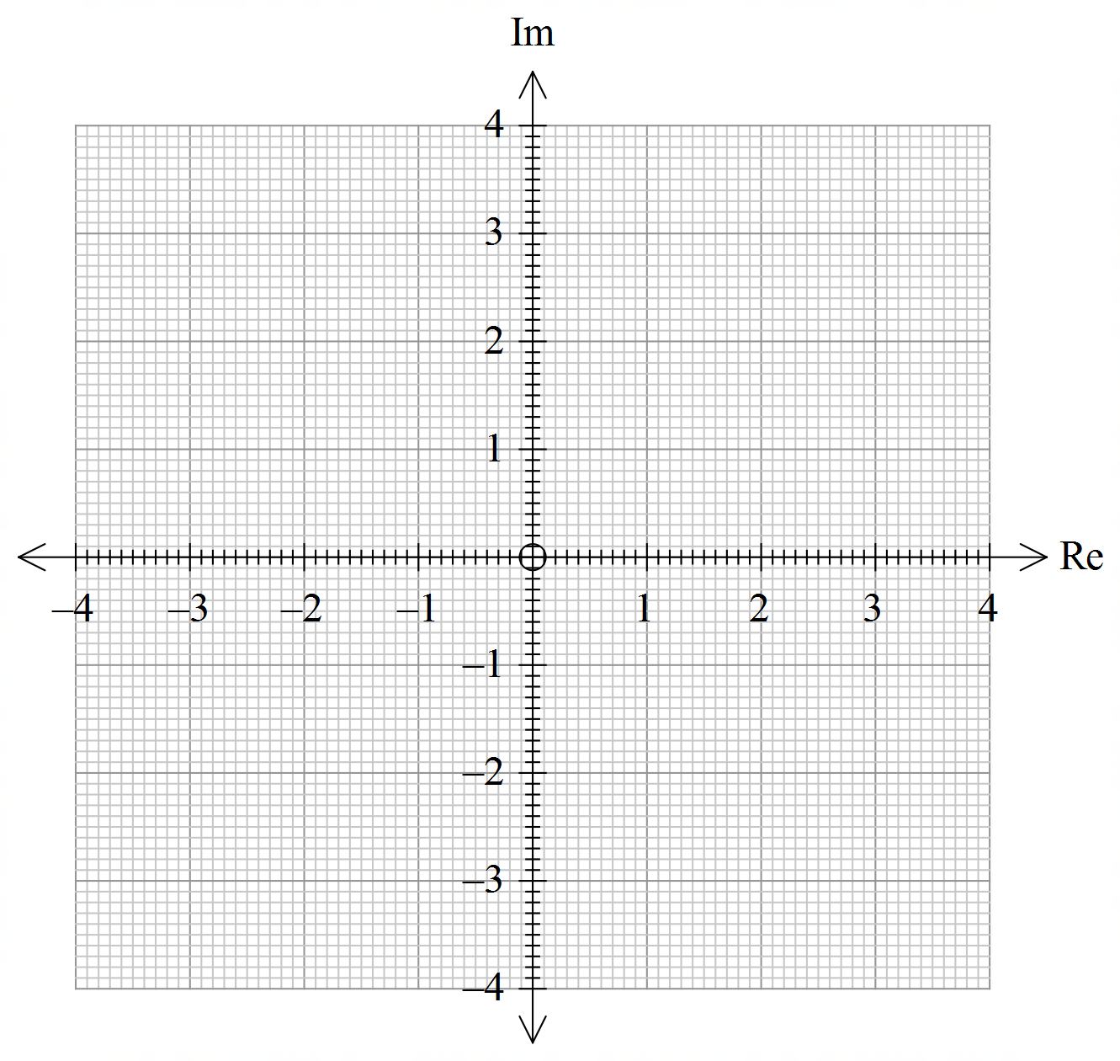

b. If *z* is the complex number that satisfies both inequalities in part **a**, determine the minimum and maximum values of $\left|z\right|$.

1. **[3 marks]**

Use de Moivre’s theorem to prove $\cos\left(3θ\right)=\cos^{3}θ-3cosθ\sin^{2}θ$

1. **[6 marks]**

Determine the centre and radius of the circle described by *z,*  where $arg\left(\frac{z-1}{z+1}\right)=\frac{π}{4}$.

Hint: Investigate the Cartesian equation by letting $z=x+yi$.